**Mavzu : awk, grep, top, htop, lsof buyrug’laridan foydalanish**

Birinchi navbatda awk command ni cat command ga o’xshatib faylni o’qib olish uchun ishlatamiz

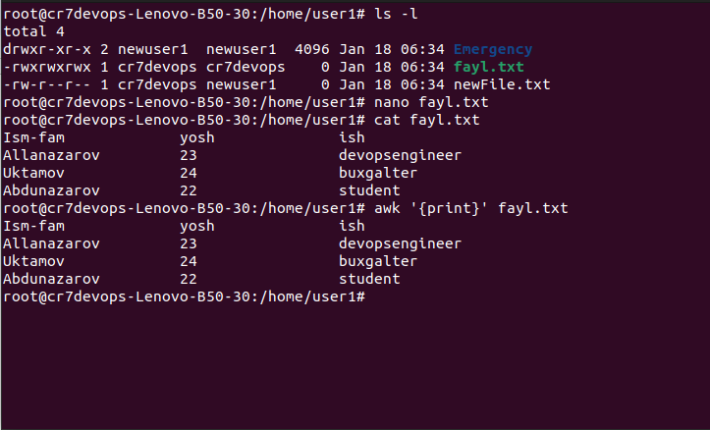

Bunda cat buyrug’i kabi barcha ustun va qatorlar natija sifatida olinadi.

Agar biz ixtoyoriy ustun ni chiqarmoqchi bo’lsak *$* belgisidan foydalanamiz

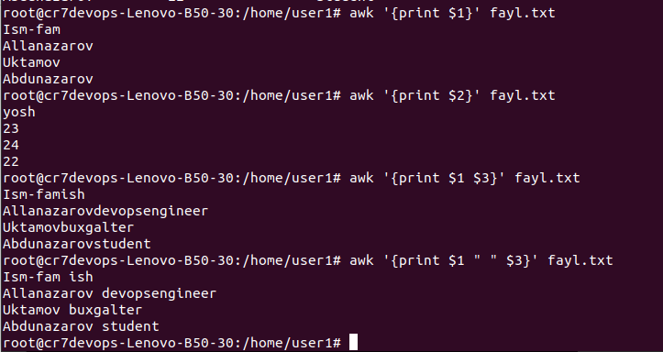

awk command ni boshqa commandlar bilan birgalikda ishlatib ko’rsak

1. ls-l with awk

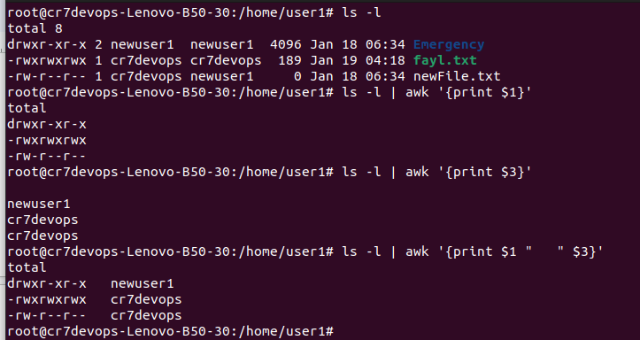

2.echo with awk

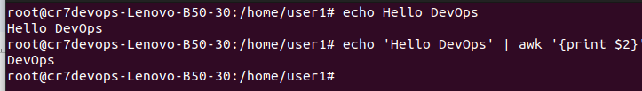

$NF -> Number final

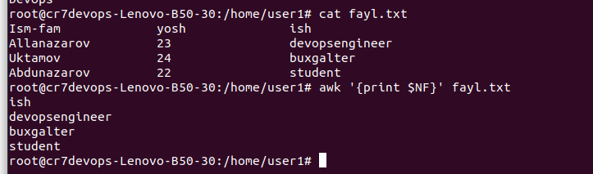

Documnetimizda agar bironta so’z bor qatorni chiqarmochi bo’lsak



Faylimizda nechta ustun borligini bilishimiz uchun *awk ‘END {print NR}’ filename.txt* buyrug’idan foydalanamiz



grep -> asosiy vazifasi file dan biron nimani izlash

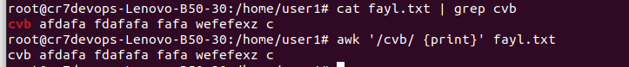

grep uses a regular expression as a pattern. The one you wrote (last one) means

* [ : the '[' character once
* .* : any character (.) any times from 0 to infinity (*)
* ] : the ']' character once

Writing \[*\] would mean "The '[' character any number of times and then the ']' character". As writing [*] wouldn't mean anything since [] is the marker for a group of characters.

vim -> text editor bo’lib fayllar bilan ishlashni yengillashtiradi.Faylga kirish uchun *vim filename.txt* yoziladi

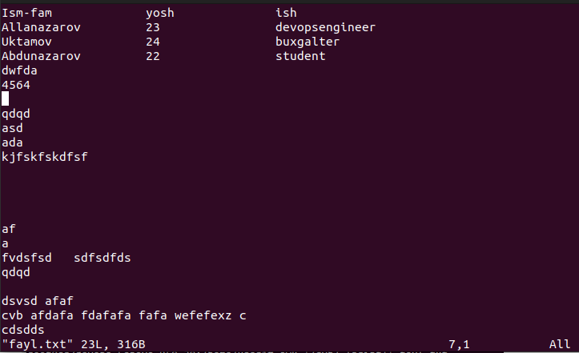

Bunda fayl ichidagi elementlarni o’zgartirish uchun *I -> insert* command dan foydalaniladi.

Bitta line o’chirish uchun *shift+D* buyrug’i bajariladi.Bu rejimda chiqish uchun *Esc* tugmasi bosiladi, Fayldan save qilib chiqish uchun katta Z harfi 2 marta bosiladi.

top va htop -> commandlari bir xil vazifani bajarib kompyuter haqida ma’lumot beradi (xotirasi, kim tomonidan foydalanilyotgni, ishlash holati …)

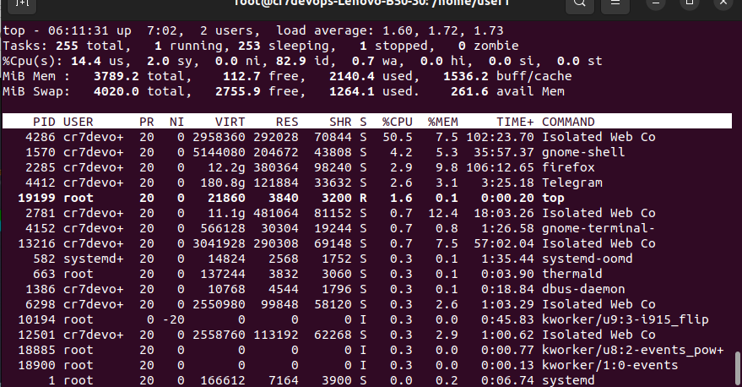

bundan chiqish uchun *q* tugmasi bosiladi.

lsof -> list open files ya’ni fayllarni list ko’rinishda ochish.

*lsof -c txt ->* txt fayliga tegishlilarni chiqarib beradi.

*lsof -p 830 ->* Id si ga tegishlilarni chiqarib beradi.

